**FUNCTIONAL AND TECHNICAL COMBINED DOCUMENTATION**

**Page (40): Monitor (Front End Url:** <http://localhost:8100/page40/Page40>)

**Functional Picture:**

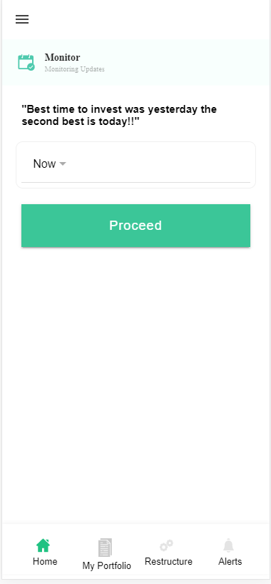

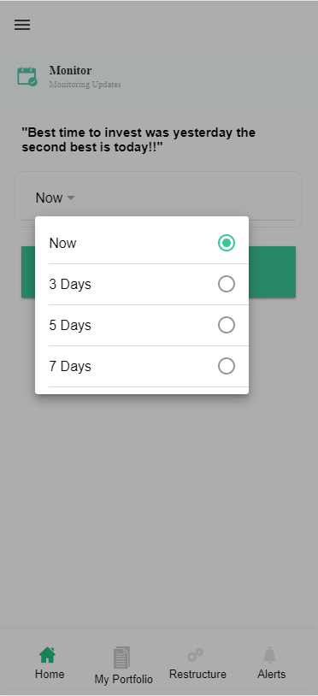

**Technical Explanation (Front End and Back End):**

**In Page40.tsx, we are calling following 3 APIs:**

1. DoItLaterAPI: see backend python file
2. AddToWatchListAPI: see backend python file
3. OnlyForWatchListAPI: see backend python file

**In this Page, the user will choose to invest the EasyVest recommended stocks if he selects the option “Now” and he will be directly redirected to “Trade Register”. Other than “Now” option, if he chose other options like “3days”, “5days” and “7days”, then it will get saved in his “Reminder(DoItLater)” database and he will be redirected to “MyPortfolio”.**

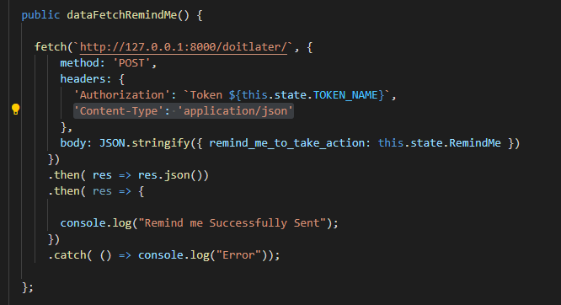**’**

**As you can see, we are calling the DoItLaterAPI using this url:** [**http://127.0.0.1:8000/doitlater/**](http://127.0.0.1:8000/doitlater/)**.**

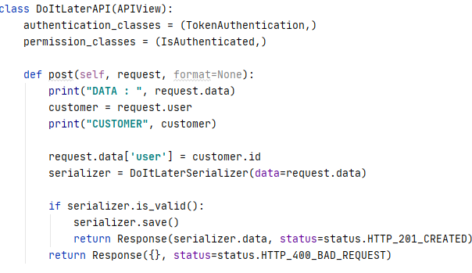

**The Above API is saving the reminder input that was given by the user in the DoItLater model database using DoItLaterSerializer. Please see the code of DoItLater database and DoItLaterSerializer given below.**

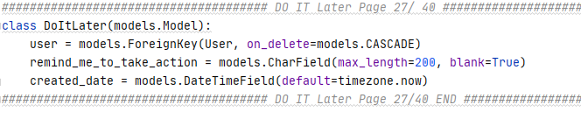

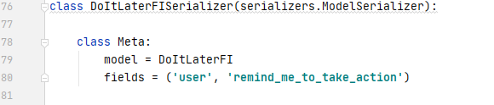

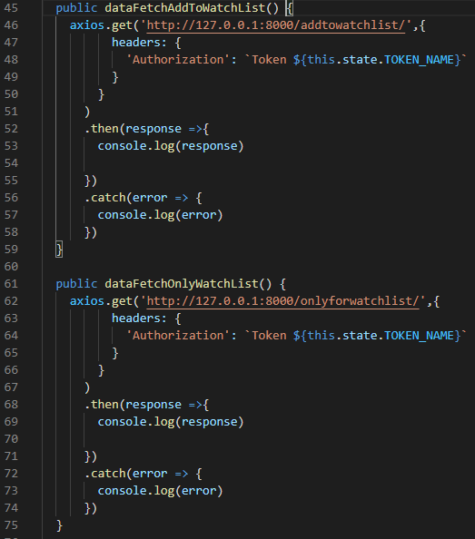

**In the above given code, which will call two API’s named** AddToWatchListAPI

**and** OnlyForWatchListAPI. These two will get trigger if the user have chosen 3day, 5day and 7days because till that time the portfolio recommendation will get saved to our MyHoldingOrWatchlist and WatchList database.

Please refer to the below code.

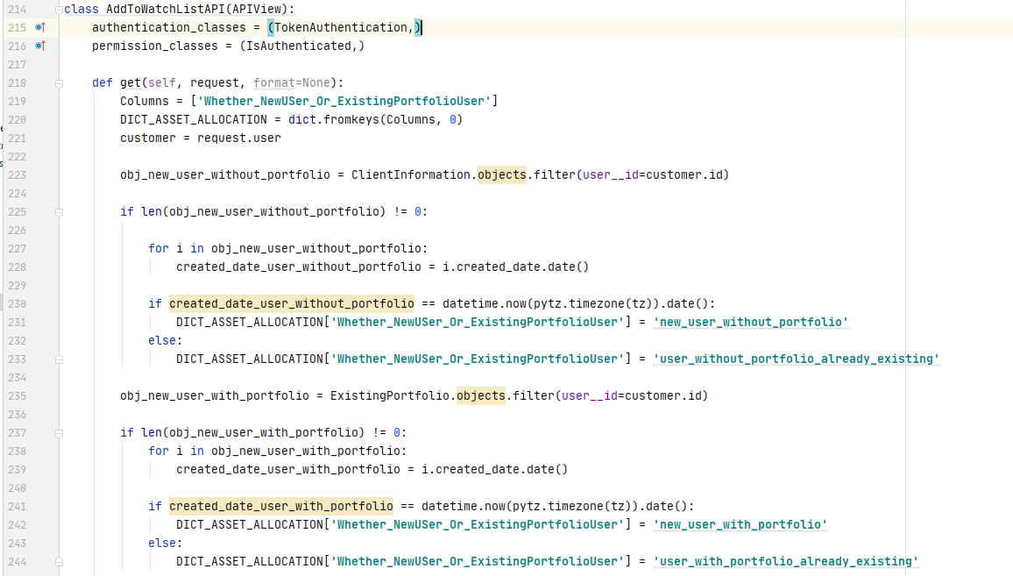

**1]From Line Number 223 to 233, we are checking the type of the user who do not have his own portfolio using the ClientInformation database model.**

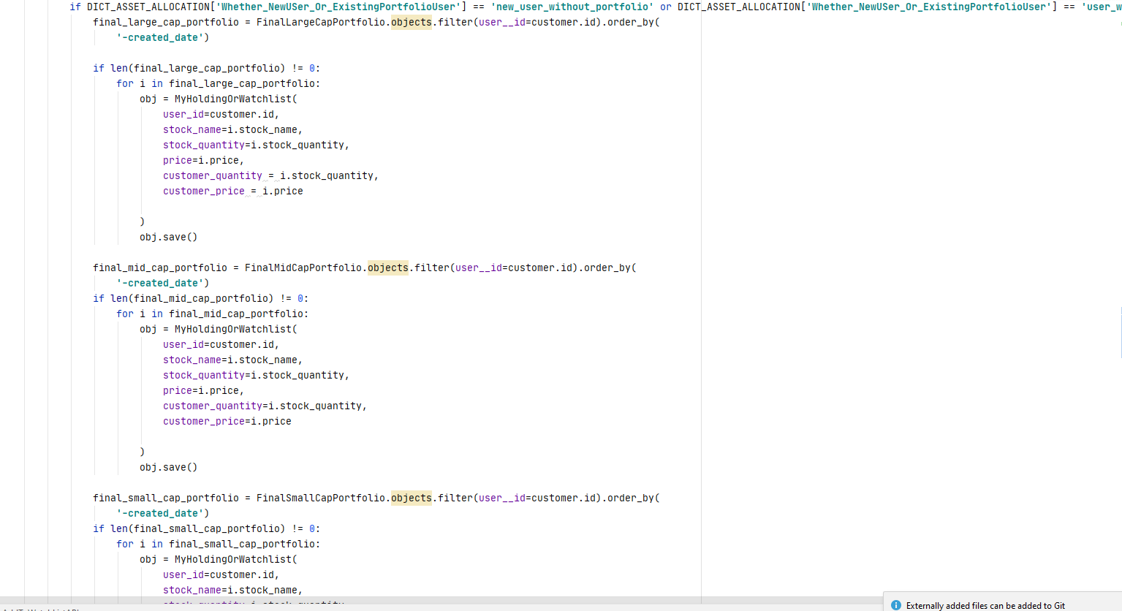

**Please Look on Line Number 248 to 294. If the user is either “new_user_without_portfolio” or “user_without_portfolio_already_existing”, then we are copying the LargeCap, MidCap and SmallCap portfolio into MyHoldingOrWatchList model database.**

**2]Now on the other hand from line number 235 to 244, we are checking the type of the user who has his own portfolio using ExistingPortfolio model database.**

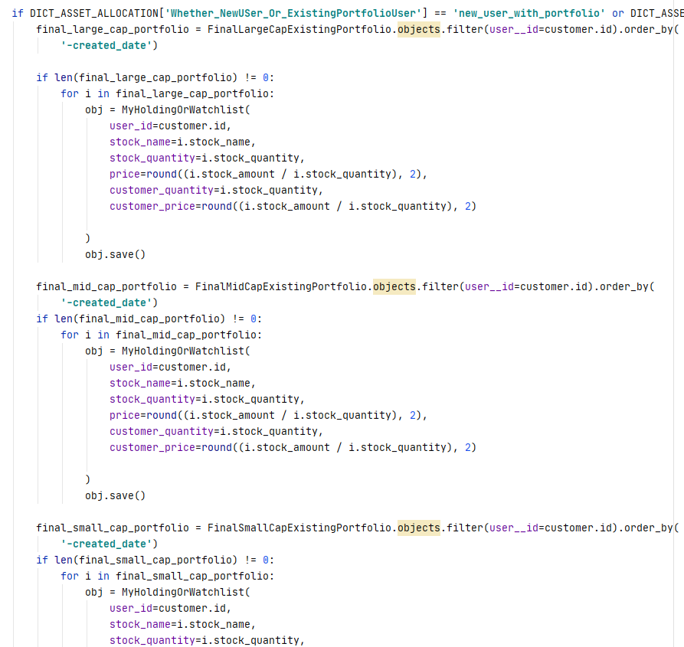

**Please Look on Line Number 296 to 341. If the user is either “new_user_with_portfolio” or “user_with_portfolio_already_existing”, then we are copying the LargeCapExisting, MidCapExisting and SmallCapExisting portfolio into MyHoldingOrWatchList model database.**

**DONE!!!**